

SOFTWARE DESIGN SPECIFICATION
Project Name: Ralsei Coach House System

– Hanoi, July 2026 –

Table of Contents
I. Record of Changes 3
II. Software Design Document 4
1. High Level Design 4
1.1 Software Architecture 4
1.2 Package Diagram 6
1.3 Database Design 8

I. Record of Changes
Date | A*  M, D | In charge | Change Description
25/6 | A | Hà | 1.1. Software Architecture
25/6 | A | Đức | 1.2. Package Diagram
25/6 | A | Trung | 1.3. Database Design
13/7 | M | Hà | 1.1. Software Architecture  1.3. Database Design
*A - Added M - Modified D - Deleted

II. Software Design Document

1. High Level Design

1.1 Software Architecture
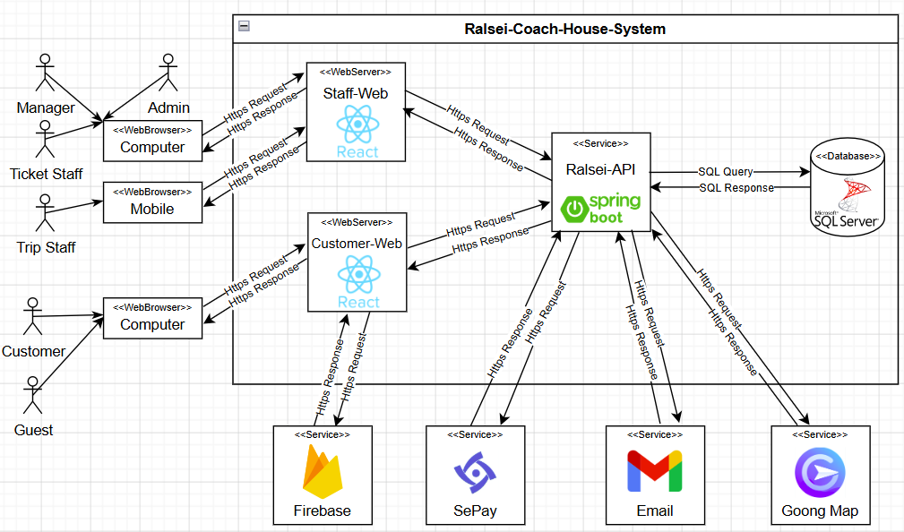
Figure 1.1: Software Architecture for Ralsei Coach House System
Architecture descriptions
No | Sub-system | Description
01 | API Service | Backend service developed using Spring Boot that provides RESTful APIs for business operations such as user management, ticket booking, payment processing, trip management, and communication with external services.
02 | Customer Website | React-based web application that allows customers to register, authenticate, search routes, book tickets, make payments, view booking history, and manage personal information.
03 | Staff Website | React-based web application used by staff members to manage routes, schedules, vehicles, bookings, customer information, and operational activities of the bus transportation system.
04 | Database | Centralized data storage system responsible for persisting application data, including user accounts, bookings, tickets, routes, schedules, payments, and system configurations.
05 | External Authentication Service | Third-party authentication service (Firebase Authentication) used for customer login, registration, identity verification, and secure token management.
06 | External Payment Service | Third-party payment service (SePay) used to process online payments, generate payment requests, and notify the system of successful payment transactions through webhooks.
07 | External Email Service | Third-party email service used to send notifications such as booking confirmations, payment confirmations, ticket updates, and other customer-related communications.
08 | Goong Maps API | A location-based service provider that integrates mapping data and geospatial intelligence, specifically optimized for the Vietnam region.

1.2 Package Diagram
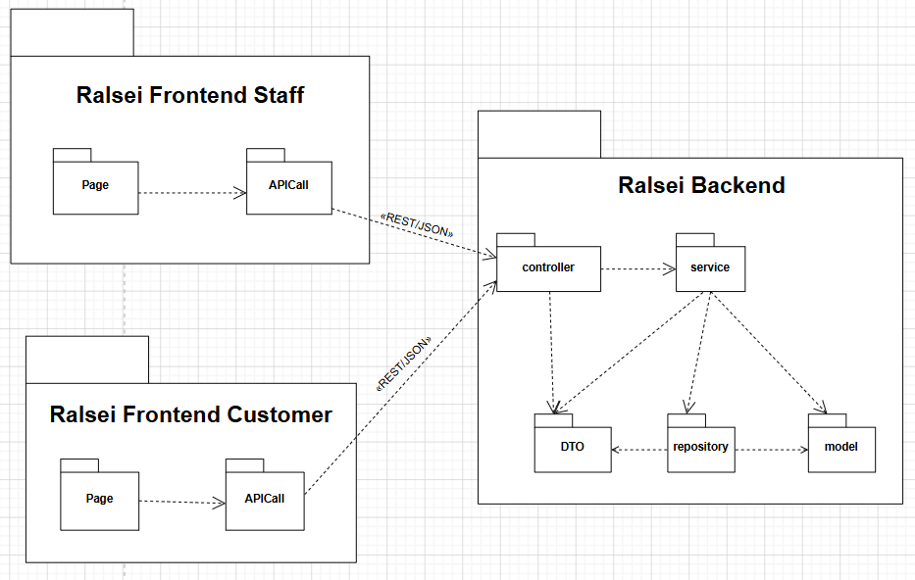
Figure 1.2: Package Diagram for Ralsei Coach House System
Package descriptions
No | Package | Description
01 | Model | Defines the data entities that map directly to the database tables, managing the core state and business rules of domain objects.
02 | Controller | Intercepts incoming requests from clients, delegates processing to the appropriate services, and returns the formatted responses.
03 | DTO | Encapsulates data structures optimized for transferring data between layers or network boundaries, ensuring internal model encapsulation and security.
04 | Service | Contains the core business logic of the application, orchestrating complex workflows and managing transaction boundaries.
05 | Repository | Provides an abstraction layer for database access, handling data persistence, CRUD operations, and execution of database queries.
06 | Page | Provides an abstraction layer for database access, handling data persistence, CRUD operations, and execution of database queries.
07 | API | Exposes RESTful endpoints to enable integration for single-page applications (SPAs), mobile clients, or third-party external systems.

1.3 Database Design

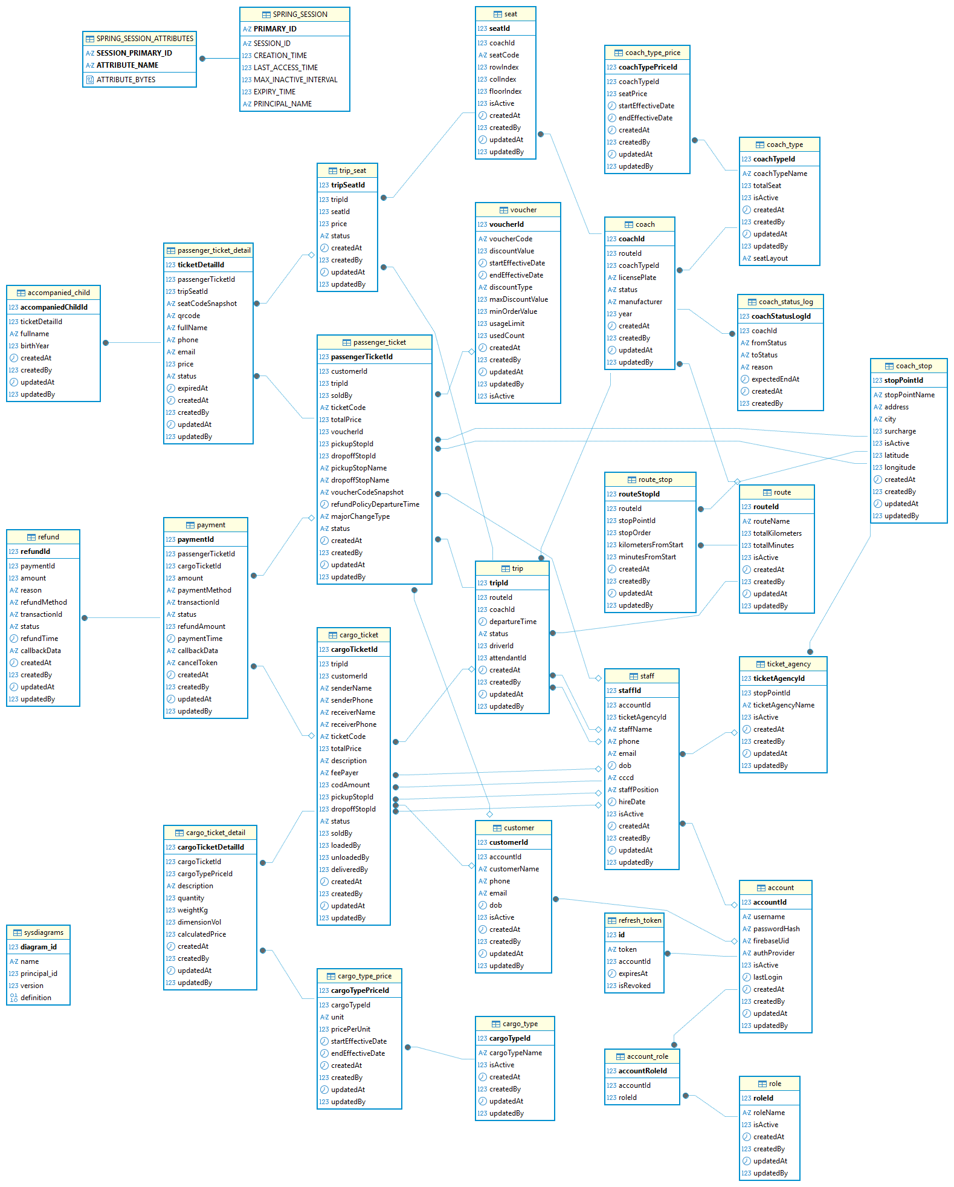

Figure 1.3: Database Design for Ralsei Coach House System

1.3.1 account
Stores user account credentials, authentication methods, and status.
No | Field | PK | FK | UN | NN | Description
01 | accountId | X |  |  | X | Unique identifier for the account.
02 | username |  |  | X | X | Unique username for login.
03 | passwordHash |  |  |  |  | Bcrypt hash of the password (for local auth).
04 | firebaseUid |  |  | X |  | Unique identifier from Firebase.
05 | authProvider |  |  |  | X | Authentication method (local, firebase, google, facebook).
06 | isActive |  |  |  | X | Indicates if the account is active.
07 | lastLogin |  |  |  |  | Timestamp of the last login.
08 | createdAt |  |  |  |  | Timestamp when the record was created.
09 | createdBy |  |  |  |  | ID of the user who created the record.
10 | updatedAt |  |  |  |  | Timestamp when the record was last updated.
11 | updatedBy |  |  |  |  | ID of the user who last updated the record.

1.3.2 role
Defines user roles and permissions within the system.
No | Field | PK | FK | UN | NN | Description
01 | roleId | X |  |  | X | Unique identifier for the role.
02 | roleName |  |  | X | X | Unique name of the role.
03 | isActive |  |  |  | X | Indicates if the role is active.
04 | createdAt |  |  |  |  | Timestamp when the record was created.
05 | createdBy |  |  |  |  | ID of the user who created the record.
06 | updatedAt |  |  |  |  | Timestamp when the record was last updated.
07 | updatedBy |  |  |  |  | ID of the user who last updated the record.

1.3.3 voucher
Manages discount vouchers, their limits, and validity periods.
No | Field | PK | FK | UN | NN | Description
01 | voucherId | X |  |  | X | Unique identifier for the voucher.
02 | voucherCode |  |  | X | X | Unique code applied by users for discounts.
03 | discountValue |  |  |  | X | The value of the discount applied.
04 | startEffectiveDate |  |  |  | X | Start date when the voucher becomes valid.
05 | endEffectiveDate |  |  |  | X | End date when the voucher expires.
06 | discountType |  |  |  | X | Type of discount (PERCENT or FIXED).
07 | maxDiscountValue |  |  |  | X | Maximum limit for percentage-based discounts.
08 | minOrderValue |  |  |  | X | Minimum order value required to apply.
09 | usageLimit |  |  |  | X | Maximum total times the voucher can be used.
10 | usedCount |  |  |  | X | Current number of times the voucher was used.
11 | createdAt |  |  |  |  | Timestamp when the record was created.
12 | createdBy |  |  |  |  | ID of the user who created the record.
13 | updatedAt |  |  |  |  | Timestamp when the record was last updated.
14 | updatedBy |  |  |  |  | ID of the user who last updated the record.

1.3.4 coach_stop
Stores the physical locations of coach stops, stations, or agencies.
No | Field | PK | FK | UN | NN | Description
01 | stopPointId | X |  |  | X | Unique identifier for the stop point.
02 | stopPointName |  |  |  | X | Name of the stop or station.
03 | address |  |  |  | X | Full address of the stop.
04 | city |  |  |  | X | City where the stop is located.
05 | surcharge |  |  |  | X | Extra fee applied for pick-up/drop-off at this stop.
06 | isActive |  |  |  | X | Indicates if the stop is currently active.
07 | latitude |  |  |  | X | GPS latitude coordinate.
08 | longitude |  |  |  | X | GPS longitude coordinate.
09 | createdAt |  |  |  |  | Timestamp when the record was created.
10 | createdBy |  |  |  |  | ID of the user who created the record.
11 | updatedAt |  |  |  |  | Timestamp when the record was last updated.
12 | updatedBy |  |  |  |  | ID of the user who last updated the record.

1.3.5 route
Defines the main travel routes, their distance, and expected duration.
No | Field | PK | FK | UN | NN | Description
01 | routeId | X |  |  | X | Unique identifier for the route.
02 | routeName |  |  |  | X | Descriptive name of the route.
03 | totalKilometers |  |  |  | X | Total distance of the route in kilometers.
04 | totalMinutes |  |  |  | X | Total estimated travel time in minutes.
05 | isActive |  |  |  | X | Indicates if the route is actively operated.
06 | createdAt |  |  |  |  | Timestamp when the record was created.
07 | createdBy |  |  |  |  | ID of the user who created the record.
08 | updatedAt |  |  |  |  | Timestamp when the record was last updated.
09 | updatedBy |  |  |  |  | ID of the user who last updated the record.

1.3.6 coach_type
Defines categories/types of coaches (e.g., Limousine, Sleeper).
No | Field | PK | FK | UN | NN | Description
01 | coachTypeId | X |  |  | X | Unique identifier for the coach type.
02 | coachTypeName |  |  | X | X | Name of the coach type.
03 | totalSeat |  |  |  | X | Total number of seats available in this type.
04 | isActive |  |  |  | X | Indicates if the coach type is in use.
05 | createdAt |  |  |  |  | Timestamp when the record was created.
06 | createdBy |  |  |  |  | ID of the user who created the record.
07 | updatedAt |  |  |  |  | Timestamp when the record was last updated.
08 | updatedBy |  |  |  |  | ID of the user who last updated the record.
09 | seatLayout |  |  |  |  | JSON/String defining the visual layout of seats.

1.3.7 cargo_type
Categorizes the types of cargo/freight that can be transported.
No | Field | PK | FK | UN | NN | Description
01 | cargoTypeId | X |  |  | X | Unique identifier for the cargo type.
02 | cargoTypeName |  |  |  | X | Descriptive name of the cargo type.
03 | isActive |  |  |  | X | Indicates if the cargo type is active.
04 | createdAt |  |  |  |  | Timestamp when the record was created.
05 | createdBy |  |  |  |  | ID of the user who created the record.
06 | updatedAt |  |  |  |  | Timestamp when the record was last updated.
07 | updatedBy |  |  |  |  | ID of the user who last updated the record.

1.3.8 account_role
Associative table linking accounts to their respective roles.
No | Field | PK | FK | UN | NN | Description
01 | accountRoleId | X |  |  | X | Unique identifier for the record.
02 | accountId |  | X | X | X | ID of the account (part of unique pair).
03 | roleId |  | X | X | X | ID of the assigned role (part of unique pair).

1.3.9 customer
Stores detailed personal information about customers.
No | Field | PK | FK | UN | NN | Description
01 | customerId | X |  |  | X | Unique identifier for the customer.
02 | accountId |  | X | X |  | Associated account ID (if registered).
03 | customerName |  |  |  | X | Full name of the customer.
04 | phone |  |  |  |  | Phone number of the customer.
05 | email |  |  |  |  | Email address of the customer.
06 | dob |  |  |  |  | Date of birth.
07 | isActive |  |  |  | X | Indicates if the customer record is active.
08 | createdAt |  |  |  |  | Timestamp when the record was created.
09 | createdBy |  |  |  |  | ID of the user who created the record.
10 | updatedAt |  |  |  |  | Timestamp when the record was last updated.
11 | updatedBy |  |  |  |  | ID of the user who last updated the record.

1.3.10 ticket_agency
Represents agency branches authorized to sell tickets at specific stops.
No | Field | PK | FK | UN | NN | Description
01 | ticketAgencyId | X |  |  | X | Unique identifier for the agency.
02 | stopPointId |  | X |  | X | ID of the physical stop point for this agency.
03 | ticketAgencyName |  |  |  | X | Name of the ticket agency.
04 | isActive |  |  |  | X | Indicates if the agency is operational.
05 | createdAt |  |  |  |  | Timestamp when the record was created.
06 | createdBy |  |  |  |  | ID of the user who created the record.
07 | updatedAt |  |  |  |  | Timestamp when the record was last updated.
08 | updatedBy |  |  |  |  | ID of the user who last updated the record.

1.3.11 staff
Stores information regarding employees, including drivers and ticket staff.
No | Field | PK | FK | UN | NN | Description
01 | staffId | X |  |  | X | Unique identifier for the staff member.
02 | accountId |  | X | X |  | Associated system account ID for login.
03 | ticketAgencyId |  | X |  |  | ID of the agency they work at (if applicable).
04 | staffName |  |  |  | X | Full name of the staff member.
05 | phone |  |  |  | X | Contact phone number.
06 | email |  |  |  |  | Email address.
07 | dob |  |  |  |  | Date of birth.
08 | cccd |  |  |  |  | Citizen identity card number.
09 | staffPosition |  |  |  | X | Position (DRIVER, ATTENDANT, TICKET_STAFF, etc).
10 | hireDate |  |  |  | X | Date when the staff member was hired.
11 | isActive |  |  |  | X | Indicates if the staff member is actively employed.
12 | createdAt |  |  |  |  | Timestamp when the record was created.
13 | createdBy |  |  |  |  | ID of the user who created the record.
14 | updatedAt |  |  |  |  | Timestamp when the record was last updated.
15 | updatedBy |  |  |  |  | ID of the user who last updated the record.

1.3.12 route_stop
Defines the sequential order of stops and distances along a route.
No | Field | PK | FK | UN | NN | Description
01 | routeStopId | X |  |  | X | Unique identifier for the route stop mapping.
02 | routeId |  | X |  | X | Associated route ID.
03 | stopPointId |  | X |  | X | Associated stop point ID.
04 | stopOrder |  |  |  | X | Sequential order of this stop on the route.
05 | kilometersFromStart |  |  |  | X | Cumulative distance from the route's origin.
06 | minutesFromStart |  |  |  | X | Cumulative travel time from the route's origin.
07 | createdAt |  |  |  |  | Timestamp when the record was created.
08 | createdBy |  |  |  |  | ID of the user who created the record.
09 | updatedAt |  |  |  |  | Timestamp when the record was last updated.
10 | updatedBy |  |  |  |  | ID of the user who last updated the record.

1.3.13 coach_type_price
Manages the pricing history and current fares based on coach types.
No | Field | PK | FK | UN | NN | Description
01 | coachTypePriceId | X |  |  | X | Unique identifier for the pricing configuration.
02 | coachTypeId |  | X | X | X | ID of the coach type (part of unique constraint).
03 | seatPrice |  |  |  | X | Price per seat.
04 | startEffectiveDate |  |  | X | X | Date when this pricing takes effect.
05 | endEffectiveDate |  |  |  | X | Date when this pricing expires.
06 | createdAt |  |  |  |  | Timestamp when the record was created.
07 | createdBy |  |  |  |  | ID of the user who created the record.
08 | updatedAt |  |  |  |  | Timestamp when the record was last updated.
09 | updatedBy |  |  |  |  | ID of the user who last updated the record.

1.3.14 cargo_type_price
Manages the unit pricing for transporting different types of cargo.
No | Field | PK | FK | UN | NN | Description
01 | cargoTypePriceId | X |  |  | X | Unique identifier for the cargo pricing rule.
02 | cargoTypeId |  | X |  | X | ID of the cargo type.
03 | unit |  |  |  | X | Measurement unit (e.g., kg, m3).
04 | pricePerUnit |  |  |  | X | Price applied per unit.
05 | startEffectiveDate |  |  |  | X | Date when this pricing takes effect.
06 | endEffectiveDate |  |  |  | X | Date when this pricing expires.
07 | createdAt |  |  |  |  | Timestamp when the record was created.
08 | createdBy |  |  |  |  | ID of the user who created the record.
09 | updatedAt |  |  |  |  | Timestamp when the record was last updated.
10 | updatedBy |  |  |  |  | ID of the user who last updated the record.

1.3.15 coach
Stores the physical fleet of buses/coaches and their assignment.
No | Field | PK | FK | UN | NN | Description
01 | coachId | X |  |  | X | Unique identifier for the coach.
02 | routeId |  | X |  |  | Assigned main route ID (if fixed).
03 | coachTypeId |  | X |  | X | ID of the coach type indicating layout and capacity.
04 | licensePlate |  |  | X | X | Unique vehicle license plate number.
05 | status |  |  |  | X | Current status (ACTIVE, MAINTENANCE, RETIRED, HAVE_INCIDENT).
06 | manufacturer |  |  |  |  | Manufacturer of the vehicle.
07 | year |  |  |  |  | Manufacturing year.
08 | createdAt |  |  |  |  | Timestamp when the record was created.
09 | createdBy |  |  |  |  | ID of the user who created the record.
10 | updatedAt |  |  |  |  | Timestamp when the record was last updated.
11 | updatedBy |  |  |  |  | ID of the user who last updated the record.

1.3.16 coach_status_log
Maintains an audit trail of a coach's status changes (e.g., maintenance).
No | Field | PK | FK | UN | NN | Description
01 | coachStatusLogId | X |  |  | X | Unique identifier for the log entry.
02 | coachId |  | X |  | X | ID of the associated coach.
03 | fromStatus |  |  |  |  | Previous status of the coach.
04 | toStatus |  |  |  | X | New applied status of the coach.
05 | reason |  |  |  | X | Description or reason for the status change.
06 | expectedEndAt |  |  |  |  | Expected time for the status to revert (e.g., end of maintenance).
07 | createdAt |  |  |  |  | Timestamp when the log was generated.
08 | createdBy |  |  |  |  | ID of the user who triggered the status change.

1.3.17 seat
Defines individual seat entities, their codes, and spatial coordinates inside a coach.
No | Field | PK | FK | UN | NN | Description
01 | seatId | X |  |  | X | Unique identifier for the seat.
02 | coachId |  | X | X | X | ID of the coach (part of unique matrix constraint).
03 | seatCode |  |  | X | X | Display code of the seat (e.g., A1, B2).
04 | rowIndex |  |  | X | X | Row position of the seat.
05 | colIndex |  |  | X | X | Column position of the seat.
06 | floorIndex |  |  | X | X | Floor level of the seat (1 or 2).
07 | isActive |  |  |  | X | Indicates if the seat is physically usable.
08 | createdAt |  |  |  |  | Timestamp when the record was created.
09 | createdBy |  |  |  |  | ID of the user who created the record.
10 | updatedAt |  |  |  |  | Timestamp when the record was last updated.
11 | updatedBy |  |  |  |  | ID of the user who last updated the record.

1.3.18 trip
Represents an actual scheduled run of a coach on a route at a specific time.
No | Field | PK | FK | UN | NN | Description
01 | tripId | X |  |  | X | Unique identifier for the trip.
02 | routeId |  | X |  | X | ID of the route taken.
03 | coachId |  | X |  | X | ID of the operating coach.
04 | departureTime |  |  |  | X | Scheduled date and time of departure.
05 | status |  |  |  | X | Current state (SCHEDULED, IN_PROGRESS, etc).
06 | driverId |  | X |  |  | ID of the assigned driver staff.
07 | attendantId |  | X |  |  | ID of the assigned attendant staff.
08 | createdAt |  |  |  |  | Timestamp when the record was created.
09 | createdBy |  |  |  |  | ID of the user who created the record.
10 | updatedAt |  |  |  |  | Timestamp when the record was last updated.
11 | updatedBy |  |  |  |  | ID of the user who last updated the record.

1.3.19 trip_seat
Represents the snapshot/state of individual seats on a specific trip instance.
No | Field | PK | FK | UN | NN | Description
01 | tripSeatId | X |  |  | X | Unique identifier for the trip's seat state.
02 | tripId |  | X | X | X | ID of the trip (part of a unique pair).
03 | seatId |  | X | X | X | ID of the physical seat (part of unique pair).
04 | price |  |  |  | X | Price snapshotted for this specific seat on this trip.
05 | status |  |  |  | X | State (AVAILABLE, LOCKED, SOLD).
06 | createdAt |  |  |  |  | Timestamp when the record was created.
07 | createdBy |  |  |  |  | ID of the user who created the record.
08 | updatedAt |  |  |  |  | Timestamp when the record was last updated.
09 | updatedBy |  |  |  |  | ID of the user who last updated the record.

1.3.20 passenger_ticket
Master record for passenger bookings covering one or multiple seats.
No | Field | PK | FK | UN | NN | Description
01 | passengerTicketId | X |  |  | X | Unique identifier for the booking ticket.
02 | customerId |  | X |  |  | ID of the customer who booked.
03 | tripId |  | X |  | X | ID of the trip the ticket is for.
04 | soldBy |  | X |  |  | ID of the staff member who sold it (if at the counter).
05 | ticketCode |  |  | X | X | Unique alphanumeric code for the ticket.
06 | totalPrice |  |  |  | X | Total calculated cost of the ticket order.
07 | voucherId |  | X |  |  | ID of the applied discount voucher.
08 | pickupStopId |  | X |  | X | ID of the selected boarding stop.
09 | dropoffStopId |  | X |  | X | ID of the selected alighting stop.
10 | pickupStopName |  |  |  | X | Snapshotted name of the boarding stop.
11 | dropoffStopName |  |  |  | X | Snapshotted name of the alighting stop.
12 | voucherCodeSnapshot |  |  |  |  | Snapshotted string of the used voucher code.
13 | refundPolicyDepartureTime |  |  |  |  | Snapshotted time base for refund calculations.
14 | majorChangeType |  |  |  |  | Log of structural changes (TRANSFER_TRIP or CANCEL_PARTIAL).
15 | status |  |  |  | X | Lifecycle status of the ticket (PENDING, CONFIRMED, etc).
16 | createdAt |  |  |  |  | Timestamp when the record was created.
17 | createdBy |  |  |  |  | ID of the user who created the record.
18 | updatedAt |  |  |  |  | Timestamp when the record was last updated.
19 | updatedBy |  |  |  |  | ID of the user who last updated the record.

1.3.21 cargo_ticket
Master record for freight/cargo shipment orders.
No | Field | PK | FK | UN | NN | Description
01 | cargoTicketId | X |  |  | X | Unique identifier for the cargo order.
02 | tripId |  | X |  |  | ID of the trip the cargo is loaded onto.
03 | customerId |  | X |  |  | ID of the customer creating the shipment.
04 | senderName |  |  |  | X | Name of the person sending the cargo.
05 | senderPhone |  |  |  | X | Phone of the sender.
06 | receiverName |  |  |  | X | Name of the person receiving the cargo.
07 | receiverPhone |  |  |  | X | Phone of the receiver.
08 | ticketCode |  |  | X | X | Unique tracking code for the shipment.
09 | totalPrice |  |  |  | X | Total shipping fee.
10 | description |  |  |  |  | General notes about the cargo.
11 | feePayer |  |  |  | X | Specifies who pays the shipping fee (SENDER or RECEIVER).
12 | codAmount |  |  |  | X | Cash On Delivery amount to collect.
13 | pickupStopId |  |  |  | X | ID of the origin agency stop.
14 | dropoffStopId |  |  |  | X | ID of the destination agency stop.
15 | status |  |  |  | X | Delivery lifecycle state (RECEIVED, LOADED, etc).
16 | soldBy |  | X |  | X | Staff ID who received the order.
17 | loadedBy |  | X |  |  | Staff ID who loaded the cargo onto the bus.
18 | unloadedBy |  | X |  |  | Staff ID who unloaded the cargo.
19 | deliveredBy |  | X |  |  | Staff ID who handed it to the receiver.
20 | createdAt |  |  |  |  | Timestamp when the record was created.
21 | createdBy |  |  |  |  | ID of the user who created the record.
22 | updatedAt |  |  |  |  | Timestamp when the record was last updated.
23 | updatedBy |  |  |  |  | ID of the user who last updated the record.

1.3.22 passenger_ticket_detail
Breakdown of the master passenger ticket per individual seat/passenger.
No | Field | PK | FK | UN | NN | Description
01 | ticketDetailId | X |  |  | X | Unique identifier for the detail line.
02 | passengerTicketId |  | X |  | X | ID of the parent passenger ticket.
03 | tripSeatId |  | X |  |  | ID of the specific reserved trip seat.
04 | seatCodeSnapshot |  |  |  | X | Fixed string representation of the reserved seat.
05 | qrcode |  |  |  |  | Data string for check-in QR generation.
06 | fullName |  |  |  | X | Name of the passenger taking this specific seat.
07 | phone |  |  |  | X | Contact number of the passenger on this seat.
08 | email |  |  |  |  | Email of the passenger.
09 | price |  |  |  | X | Cost applied to this specific seat.
10 | status |  |  |  | X | Individual state (PENDING, CHECKED_IN, etc).
11 | expiredAt |  |  |  |  | Time limit for pending items before auto-release.
12 | createdAt |  |  |  |  | Timestamp when the record was created.
13 | createdBy |  |  |  |  | ID of the user who created the record.
14 | updatedAt |  |  |  |  | Timestamp when the record was last updated.
15 | updatedBy |  |  |  |  | ID of the user who last updated the record.

1.3.23 cargo_ticket_detail
Line items breaking down the physical items inside a cargo shipment.
No | Field | PK | FK | UN | NN | Description
01 | cargoTicketDetailId | X |  |  | X | Unique identifier for the cargo line item.
02 | cargoTicketId |  | X |  | X | ID of the parent cargo ticket.
03 | cargoTypePriceId |  | X |  | X | ID referencing the pricing tier used.
04 | description |  |  |  |  | Details of the specific package.
05 | quantity |  |  |  | X | Number of items in this package tier.
06 | weightKg |  |  |  | X | Actual physical weight in kilograms.
07 | dimensionVol |  |  |  | X | Dimensional volume measurement.
08 | calculatedPrice |  |  |  | X | Final sub-cost computed for this line item.
09 | createdAt |  |  |  |  | Timestamp when the record was created.
10 | createdBy |  |  |  |  | ID of the user who created the record.
11 | updatedAt |  |  |  |  | Timestamp when the record was last updated.
12 | updatedBy |  |  |  |  | ID of the user who last updated the record.

1.3.24 payment
Financial records capturing payment transactions for tickets and cargo.
No | Field | PK | FK | UN | NN | Description
01 | paymentId | X |  |  | X | Unique identifier for the payment.
02 | passengerTicketId |  | X |  |  | ID of the paid passenger ticket (if applicable).
03 | cargoTicketId |  | X |  |  | ID of the paid cargo ticket (if applicable).
04 | amount |  |  |  | X | Gross amount to be settled.
05 | paymentMethod |  |  |  | X | Channel used (CASH, SEPAY, BANK_TRANSFER).
06 | transactionId |  |  |  | X | Trace ID from external gateways or internal receipts.
07 | status |  |  |  | X | Status of the transfer (PENDING, COMPLETED, FAILED).
08 | refundAmount |  |  |  | X | Total value successfully returned out of this payment.
09 | paymentTime |  |  |  |  | Actual timestamp when funds were confirmed.
10 | callbackData |  |  |  |  | Raw webhook/callback response from gateways.
11 | cancelToken |  |  |  |  | Security token required to abort the payment gateway.
12 | createdAt |  |  |  |  | Timestamp when the record was created.
13 | createdBy |  |  |  |  | ID of the user who created the record.
14 | updatedAt |  |  |  |  | Timestamp when the record was last updated.
15 | updatedBy |  |  |  |  | ID of the user who last updated the record.

1.3.25 accompanied_child
Records information of children sharing a single seat with a paying adult.
No | Field | PK | FK | UN | NN | Description
01 | accompaniedChildId | X |  |  | X | Unique identifier for the child passenger record.
02 | ticketDetailId |  | X | X | X | ID of the adult's ticket detail they share a seat with.
03 | fullname |  |  |  | X | Full name of the child.
04 | birthYear |  |  |  | X | Year the child was born to verify age limits.
05 | createdAt |  |  |  |  | Timestamp when the record was created.
06 | createdBy |  |  |  |  | ID of the user who created the record.
07 | updatedAt |  |  |  |  | Timestamp when the record was last updated.
08 | updatedBy |  |  |  |  | ID of the user who last updated the record.

1.3.26 refund
Financial records capturing money returned to users for cancellations.
No | Field | PK | FK | UN | NN | Description
01 | refundId | X |  |  | X | Unique identifier for the refund order.
02 | paymentId |  | X |  | X | ID of the parent payment being partially/fully reversed.
03 | amount |  |  |  | X | Currency amount returned to the customer.
04 | reason |  |  |  |  | Text justification for the refund request.
05 | refundMethod |  |  |  | X | Channel used for the payout (CASH, SEPAY, etc).
06 | transactionId |  |  |  |  | Identifier from the bank/gateway handling the refund.
07 | status |  |  |  | X | State of the payout (PENDING, COMPLETED, FAILED).
08 | refundTime |  |  |  |  | Timestamp when the money was confirmed disbursed.
09 | callbackData |  |  |  |  | Gateway logs of the refund processing.
10 | createdAt |  |  |  |  | Timestamp when the record was created.
11 | createdBy |  |  |  |  | ID of the user who created the record.
12 | updatedAt |  |  |  |  | Timestamp when the record was last updated.
13 | updatedBy |  |  |  |  | ID of the user who last updated the record.

1.3.27 refresh_token
Stores tokens used to maintain extended authentication sessions for users.
No | Field | PK | FK | UN | NN | Description
01 | id | X |  |  | X | Unique identifier for the token record.
02 | token |  |  | X | X | The cryptographic token string.
03 | accountId |  | X |  | X | Associated user account ID.
04 | expiresAt |  |  |  | X | Datetime when the token becomes invalid.
05 | isRevoked |  |  |  | X | Flag to manually invalidate the token before expiration.

